CSA1708-ARTIFICIAL INTELLIGENCE
LAB EXPERIMENTS

Program 2: Python Program to Solve the 8-Queens Problem

Aim
To write a Python program that places eight queens on a chessboard so that no two queens attack each other.

Algorithm
- Start with an empty 8 × 8 chessboard.
- Place one queen in each row.
- Check that the queen does not share a column or diagonal with any previously placed queen.
- If a safe position is found, move to the next row.
- If no safe position is available, backtrack and try another position.
- Display the board when all eight queens are placed.

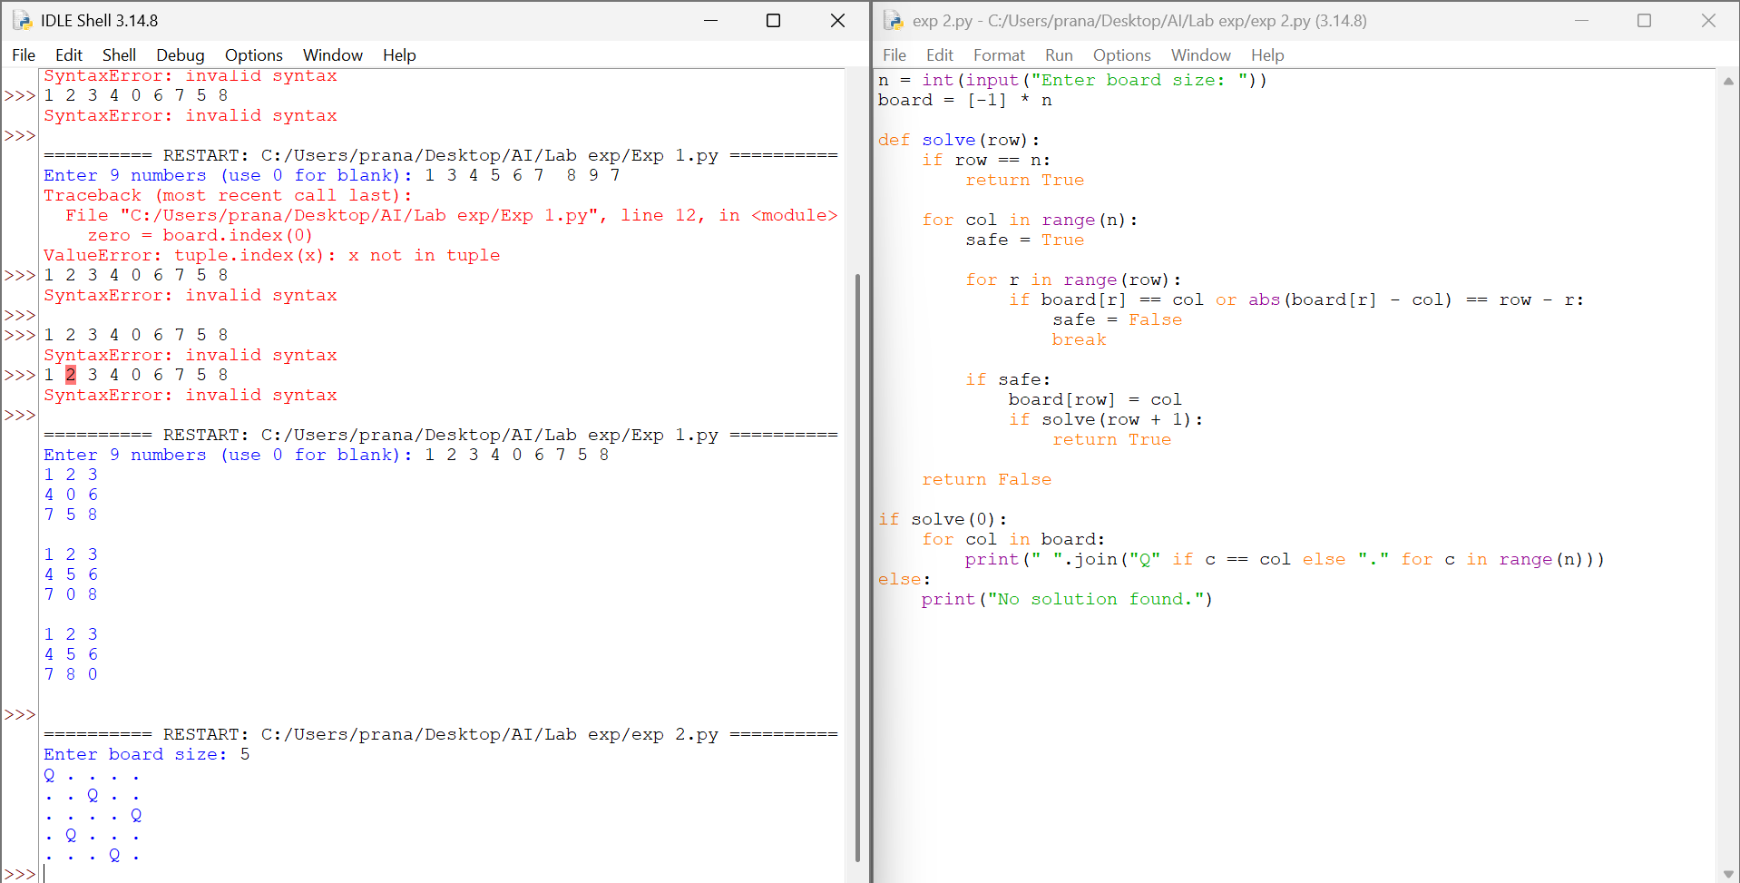

RESULT

Thus, the 8-Queens Problem was solved successfully using Python and backtracking.

